**DAILY ONLINE ACTIVITIES SUMMARY**

|  |  |  |  |  |  |  |  |  |
| --- | --- | --- | --- | --- | --- | --- | --- | --- |
| **Date:** | **02-06-2020** | | | | | **Name:** | **Anusha** | |
| **Sem & Sec** | **VIII Semester & A Section** | | | | | **USN:** | **4AL16CS014** | |
| **Online Test Summary** | | | | | | | | |
| **Subject** | | **No Test was conducted** | | | | | | |
| **Max. Marks** | | **-** | | **Score** | | | **-** | |
| **Certification Course Summary** | | | | | | | | |
| **Course** | **Robotic Process Automation** | | | | | | | |
| **Certificate Provider** | | | **Ui Path** | | **Duration** | | | **3 Hours** |
| **Coding Challenges** | | | | | | | | |
| **Problem Statement: Find an array of positive integers for the inversion count of array.** | | | | | | | | |
| **Status: COMPLETED** | | | | | | | | |
| **Uploaded the report in Github** | | | | | **YES** | | | |
| **If yes Repository name** | | | | | **anushasuvarna-014** | | | |
| **Uploaded the report in slack** | | | | | **YES** | | | |

Online Test Details:

NIL

Certification Course Details: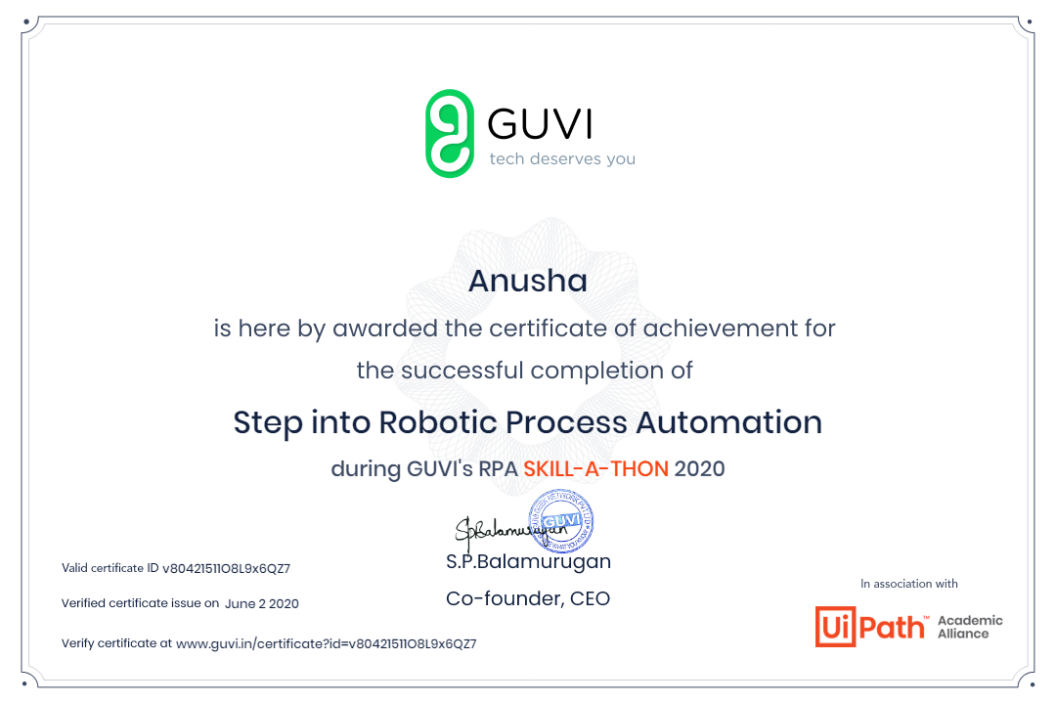

Coding Challenges Details:

|  |
| --- |
| **#include<stdio.h>** |
|  |  |
|  | **int getInvCount(int arr[], int n)** |
|  | **{** |
|  | **int inv_count = 0;** |
|  | **for (int i = 0; i < n - 1; i++)** |
|  | **for (int j = i + 1; j < n; j++)** |
|  | **if (arr[i] > arr[j])** |
|  | **inv_count++;** |
|  |  |
|  | **return inv_count;** |
|  | **}** |
|  |  |
|  | **int main(int argv, char** args)** |
|  | **{** |
|  | **int arr[] = { 2,4,1,3,5 };** |
|  | **int n = sizeof(arr) / sizeof(arr[0]);** |
|  | **printf(" Number of inversions are %d \n", getInvCount(arr, n));** |
|  | **return 0;** |
|  | **}** |